CS7637: Project 2 (Summer 2015)

**Due: June 28th at 11:59PM UTC-12 (anywhere on earth)**

Click [here](https://t-square.gatech.edu/portal/tool/e27483bf-2963-4489-80af-9ddd2350f2fc?assignmentId=/assignment/a/gtc-5ac1-e2bd-5df3-9e91-f40708f08467/9f353275-7ef9-475c-a6f8-783c02145e8f&panel=Main&sakai_action=doView_assignment) to submit your agent code, and click [here](https://t-square.gatech.edu/portal/tool/e27483bf-2963-4489-80af-9ddd2350f2fc?assignmentId=/assignment/a/gtc-5ac1-e2bd-5df3-9e91-f40708f08467/c6e6b092-393a-4c6b-bfb1-d2770ac6f8ec&panel=Main&sakai_action=doView_assignment) to submit your project reflection.

**Assignment: Solving 3x3 RPM using Verbal and/or Visual Representations.**

Make sure to read the more general project description [here](https://docs.google.com/document/d/1GkXYf6xG-jGzxM_Z5pwE2GkhCUvq369t7lmOI9YUVnQ/edit?usp=sharing) for a high-level introduction and description of the class project.

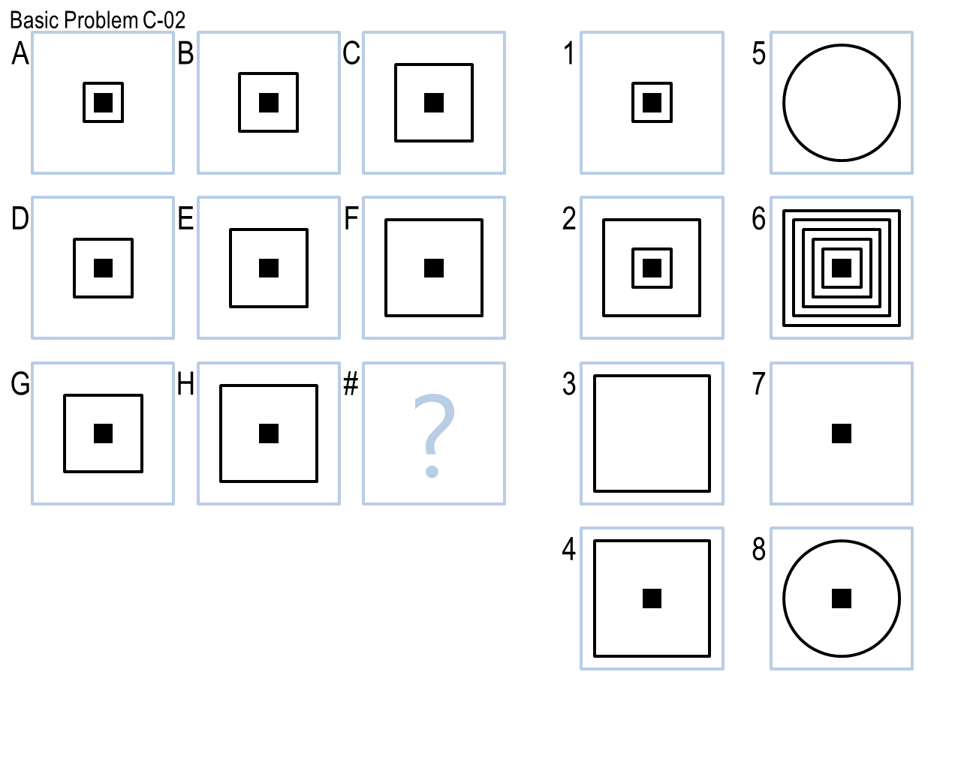

Project 2 is nearly identical to [Project 1](https://docs.google.com/document/d/1ULlFP6bsnDKNJUNJDu7DdwOxAk1CM0m3R8HSYNh9FZ4/edit?usp=sharing). Thus, please consult the Project 1 directions for the majority of your information. Everything that applied to Project 1 also applies to Project 2.

The differences in Project 2 are:

* The due date is June 28th.
* Your agent will run against Problem Sets B and C instead of just Problem Set B.
* Problem Set C is comprised of 3x3 problems rather than 2x2 problems.
* Your agent will be graded on its performance on [Basic](https://drive.google.com/file/d/0B-XdVjMuNV2GdjdJWmoxX0Y4Qmc/view?usp=sharing) Problem Set C and Test Problem Set C. It will not be graded on the other six sets it runs against.
* When submitting, you should use ‘Project2’ in the name of your .zip instead of ‘Project1’.
* If your Project 2 agent outperforms your Project 1 agent on Basic or Test Problem Set B, your Project 1 grade will be raised in accordance with the [Repeated Problem Set policy from the Overall Project Guidelines](https://docs.google.com/document/d/1GkXYf6xG-jGzxM_Z5pwE2GkhCUvq369t7lmOI9YUVnQ/edit?usp=sharing#heading=h.2u887ahws1xs).